**Topic: Convolution Neural Network (CNN)**

**Instructions**

Please share your answers filled inline in the word document. Submit Python code and R code files wherever applicable.

Please ensure you update all the details:

**Name: Upadhyay sachin Naresh**

**Batch Id: Data science\_08032021**

**Topic: Convolution Neural Network.**

1. **Business Problem**
   1. **Objective**
   2. **Constraints (if any)**
2. **Work on each feature of the dataset to create a data dictionary as displayed in the below image:**

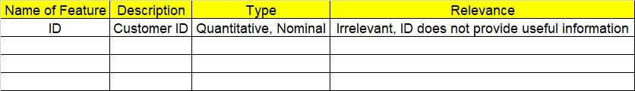

**2.1 Make a table as shown above and provide information about the features such as its Data type and its relevance to the model building, if not relevant provide reasons and provide description of the feature.**

**Using Python code perform:**

1. **Data Pre-processing**

**3.1 Data Cleaning, Feature Engineering, etc.**

**3.2 Outlier Imputation if applicable**

1. **Model Building**
   1. **Build the convolution neural network model**
   2. **Train and Test the data**
   3. **Briefly explain the model output in the documentation**

****

1. **Share the benefits/impact of the solution - how or in what way the business (client) gets benefit from the solution provided**
2. **Use Tensorflow for this assignment depending on your system configuration either tensorflowgpu or tensorflowcpu version.**

# Note:

**The assignment should be submitted in the following format:**

* **Python code**
* **Code Modularization should be maintained**
* **Documentation of the model building (elaborating on steps mentioned above)**

**Problem Statement: -**

1. Build a CNN model on CIFAR-10 dataset by applying few regularization techniques like drop out and data augmentation

2. Find out the differences between Convnet filter and the Maxpool layers

**ANSWER:**

**Convolutional layer**

The convolutional layer serves to detect (multiple) patterns in multiple sub-regions in the input field using receptive fields.

**Pooling layer**

The pooling layer serves to progressively reduce the spatial size of the representation, to reduce the number of parameters and amount of computation in the network, and hence to also control overfitting.

The intuition is that the exact location of a feature is less important than its rough location relative to other features.

3. If the input of an image is 64x64x3 which has been convolved by 10 5x5 filters with stride 1 and padding 2.

a. How many activation maps are obtained?

Ans – 10 since the dimension of filter is 10.

b. What is the size of the activation maps?

Ans- Input size = 64x64x3

Filter = 10 5x5 stride = 1 pad = 2

Formula: (N-F+2P)/stride+1

= (32 – 5 + 2x2) / 1 + 1 2P =2x2 is for pad size

= 32 spatially

So, 32x32x10 output size

c. How many parameters are calculated?

Ans –Input size = 64x64x3

Filter = 10 5x5 stride = 1 pad = 2

Each filter has 5x5x3 + 1 = 76 parameters

For 10 filters = 76x10 = 760 parameters

4. During training, I get into overfitting issues. What are the different techniques will you apply to overcome this issue and why?

**ANSWER:**

The first step when dealing with overfitting is to decrease the complexity of the model. To decrease the complexity, we can simply remove layers or reduce the number of neurons to make the network smaller. While doing this, it is important to calculate the input and output dimensions of the various layers involved in the neural network. There is no general rule on how much to remove or how large your network should be. But, if your neural network is overfitting, try making it smaller.

### 2. Early Stopping

Early stopping is a form of regularization while training a model with an iterative method, such as gradient descent. Since all the neural networks learn exclusively by using gradient descent, early stopping is a technique applicable to all the problems. This method update the model so as to make it better fit the training data with each iteration. Up to a point, this improves the model’s performance on data on the test set. Past that point however, improving the model’s fit to the training data leads to increased generalization error. Early stopping rules provide guidance as to how many iterations can be run before the model begins to overfit.

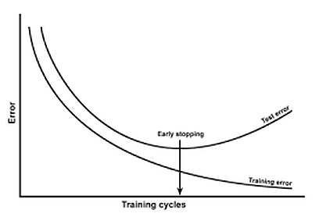

Early Stopping

This technique is shown in the above diagram. As we can see, after some iterations, test error has started to increase while the training error is still decreasing. Hence the model is overfitting. So to combat this, we stop the model at the point when this starts to happen.

### 3. Use Data Augmentation

In the case of neural networks, data augmentation simply means increasing size of the data that is increasing the number of images present in the dataset. Some of the popular image augmentation techniques are flipping, translation, rotation, scaling, changing brightness, adding noise etcetera. For a more complete reference, feel free to checkout [albumentations](https://github.com/albumentations-team/albumentations" \t "_blank) and [imgaug](https://github.com/aleju/imgaug" \t "_blank).

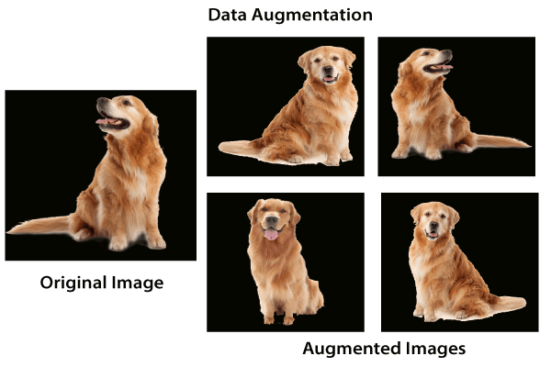

Data Augmentation

This technique is shown in the above diagram. As we can see, using data augmentation a lot of similar images can be generated. This helps in increasing the dataset size and thus reduce overfitting. The reason is that, as we add more data, the model is unable to overfit all the samples, and is forced to generalize.

### 4. Use Regularization

Regularization is a technique to reduce the complexity of the model. It does so by adding a penalty term to the loss function. The most common techniques are known as L1 and L2 regularization:

* The L1 penalty aims to minimize the absolute value of the weights. This is mathematically shown in the below formula.

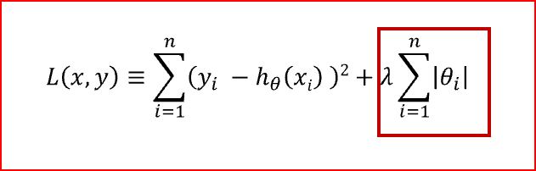

L1 Regularization

* The L2 penalty aims to minimize the squared magnitude of the weights. This is mathematically shown in the below formula.

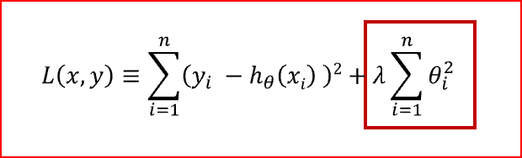

L2 Regularization

The below table compares both the regularization techniques.

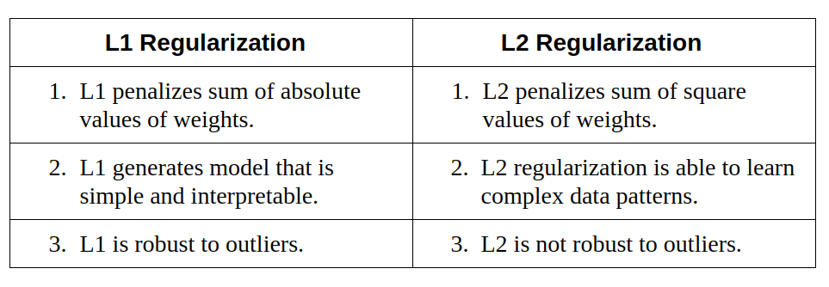

L1 vs L2 Regularization

So which technique is better at avoiding overfitting? The answer is — it depends. If the data is too complex to be modelled accurately then L2 is a better choice as it is able to learn inherent patterns present in the data. While L1 is better if the data is simple enough to be modelled accurately. For most of the computer vision problems that I have encountered, L2 regularization almost always gives better results. However, L1 has an added advantage of being robust to outliers. So the correct choice of regularization depends on the problem that we are trying to solve.

### 5. Use Dropouts

Dropout is a regularization technique that prevents neural networks from overfitting. Regularization methods like L1 and L2 reduce overfitting by modifying the cost function. Dropout on the other hand, modify the network itself. It randomly drops neurons from the neural network during training in each iteration. When we drop different sets of neurons, it’s equivalent to training different neural networks. The different networks will overfit in different ways, so the net effect of dropout will be to reduce overfitting.

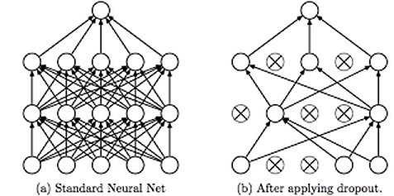

Using Dropouts

This technique is shown in the above diagram. As we can see, dropouts are used to randomly remove neurons while training of the neural network. This technique has proven to reduce overfitting to a variety of problems involving image classification, image segmentation, word embeddings, semantic matching etcetera.

### Conclusion

As a quick recap, I explained what overfitting is and why it is a common problem in neural networks. I followed it up by presenting five of the most common ways to prevent overfitting while training neural networks — simplifying the model, early stopping, data augmentation, regularization and dropouts.